# **Documentation for deploy a website on localhost using nginx**

1. Verify Nginx Installation =

**“sudo systemctl status nginx”**

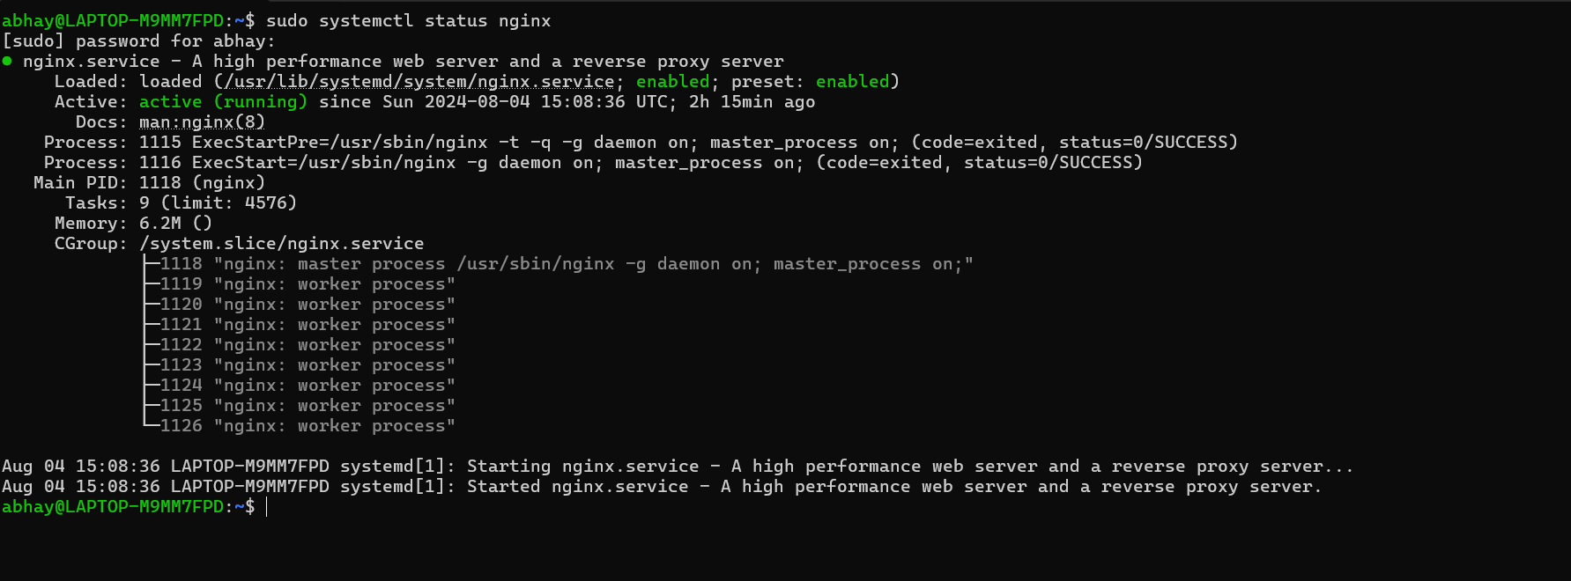

1. Create and Navigate a Directory awesomeweb =

**“sudo mkdir -p /var/www/awesomeweb”**

**“cd /var/www/awesomeweb/”**



1. Create an HTML File =

Create an index.html file inside the awesomeweb directory and add some basic HTML content. **“sudo nano index.html”**

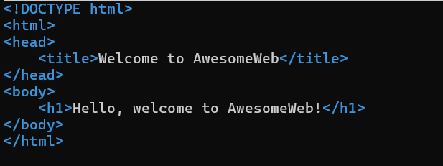

1. Set Proper Permissions

Change the ownership and permissions of your website directory.

**“sudo chown -R www-data:www-data /var/www/awesomeweb”**

**“sudo chmod -R 755 /var/www/awesomeweb”**



1. Configure Nginx to website =

Create a new Nginx server block configuration file.

**“sudo nano /etc/nginx/sites-available/awesomeweb”**

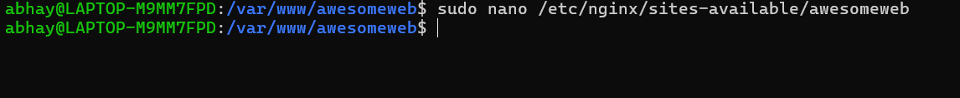

**Add the following configuration**:

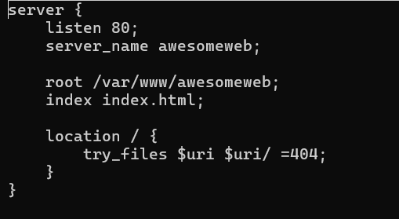

1. Enable the New Configuration =

Create a symbolic link to enable the new site.

**“sudo ln -s /etc/nginx/sites-available/awesomeweb /etc/nginx/sites-enabled/”**

1. Reload Nginx **=**

**“sudo systemctl reload nginx”**

1. Update the Hosts File =

**“sudo nano /etc/hosts”**

and add following line:

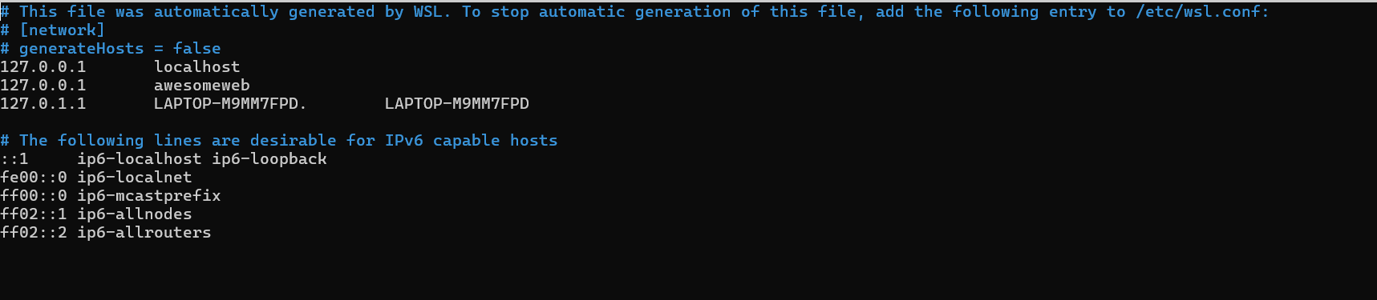

1. Verify the Setup =

**“curl** [**http://localhost**](http://localhost)**”**

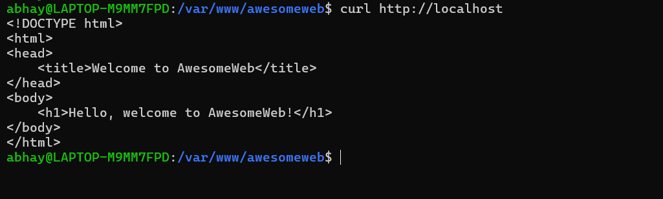

**“curl** [**http://awesomeweb**](http://awesomeweb)**”**

**ping** [**http://awesomeweb**](http://awesomeweb)

